Physical and Chemical Changes

Physical Change—the substances physical characteristics change but the substance itself does not change. The substance may change between states and still be just a physical change.
Chemical Change—the properties of a substance change making it a different substance with new properties. Energy is used or given off in the process.

Color the following picture if it is a physical change!
1. Burning a sparkler | 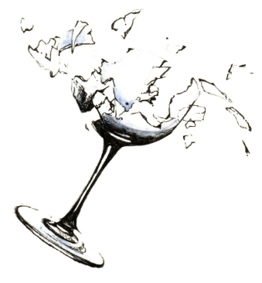  2. Breaking a glass | 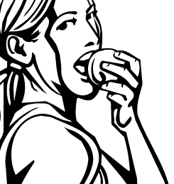  3. Eating an apple | 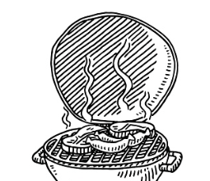  4. Grilling a steak
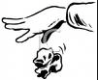  5. Crumpling a piece of paper | 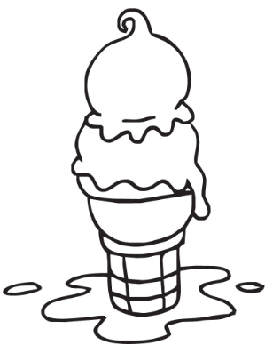  6. Melting ice cream | 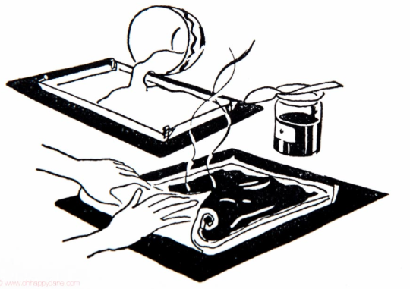  7. Baking a pumpkin roll | 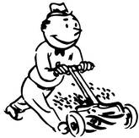  8. Mowing the grass
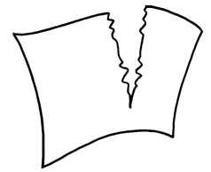  9. Tearing apart a piece of paper | 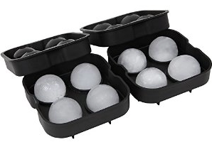  10. Water freezing into ice | 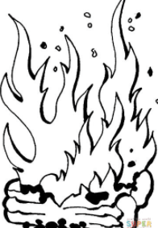  11. Burning logs | 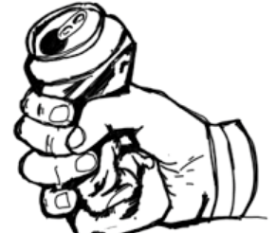  12. Crushing a can

Write the number of each item that shows a physical change. Describe the change.

# Description

_____ _________________________________________________________________________________________________________________

_____ _________________________________________________________________________________________________________________

_____ _________________________________________________________________________________________________________________

_____ _________________________________________________________________________________________________________________

_____ _________________________________________________________________________________________________________________

_____ _________________________________________________________________________________________________________________

_____ _________________________________________________________________________________________________________________

