The Four States of Matter Notes

Directions: While watching the notes video fill in the spaces in the table below.

State of Matter | Space b/w Particles | Volume | Shape | Compressibility | Particle Arrangement
Solid

Liquid
Gas
Plasma

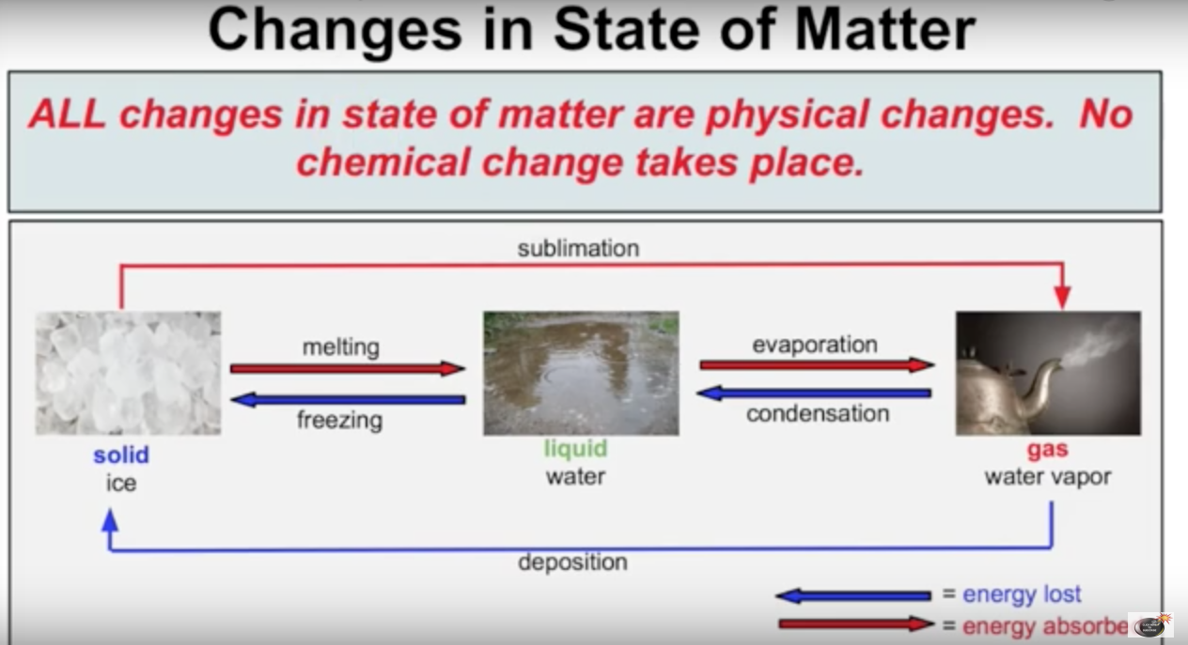

- What is Sublimation?

- What is Deposition?

