STEM Friday #9
Innovations & Cutting Engine Wear

Read the article and highlight the power words (only highlight the words the first time you see them).

After reading, discuss with a partner the benefits of this new innovation.

Write down a bulleted list of at least 10 things that are either positive or negative about this innovation and how it will help the automotive industry.

New coating for metals could cut engine wear

Substance creates a slick and tough film that decreases friction, extends life of oil

SID PERKINS

OCT 24, 2016 — 7:00 AM EST

- 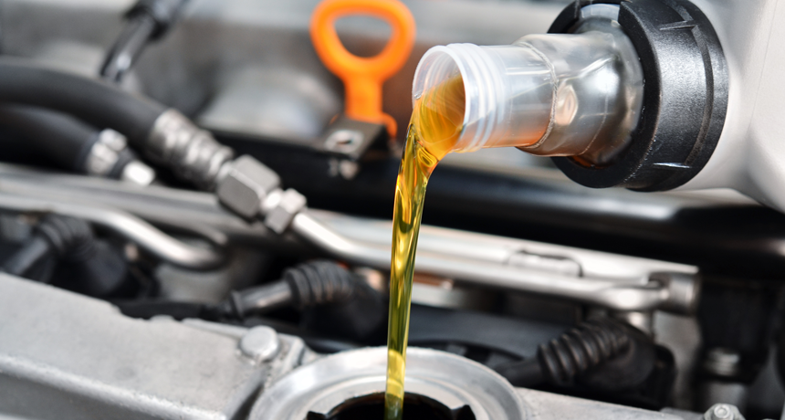

Researchers have developed a new coating for engine parts that may reduce how often drivers must change their oil.

This is one in a series presenting news on technology and innovation, made possible with generous support from the Lemelson Foundation.
Car engines need oil to reduce friction between moving parts. This lubrication keeps the parts cool and cuts down on engine wear. Now, researchers have developed a new hard coating that would be applied to engine parts before they leave the factory. This is no ordinary coating. It’s an “active” surface that’s permanently bonded to the auto parts. And it doesn’t just sit there. It interacts with motor oil to create a slick carbon film that cuts friction better than the oil would alone.
The new coating may decrease how often a driver must change the oil, scientists say. It also could help reduce the need for metal-based additives in motor oil. Today, those additives make used oil difficult to recycle.
In the extreme heat and pressure inside a running engine, those metal additives are useful. They bond to auto parts and create a slick and protective surface. That layer — together with the slippery oil — reduces friction and wear inside a vehicle’s engine, explains Ali Erdemir. He’s a materials scientist at Argonne National Laboratory in Illinois.
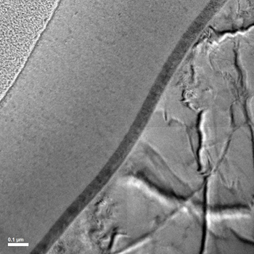
A new coating (broad band from middle left to top center) can be bonded onto engine parts (such as this piece of steel, right). This new layer is a self-healing carbon film that reduces friction and wear in vehicle engines.

The metal additives’ lack of eco-friendliness, among other factors, helped inspire Erdemir and his team to develop their innovation. The researchers created a metal-nitride coating that contains an ingredient that interacts with motor oil — and removes the need for the additives.
The reactions the coating triggers create a surface film on moving parts. That film is less permanent than the layer that forms using today’s oil additives. But the new film is also self-renewing, Erdemir notes. So when it eventually wears away, a metal ingredient in the coating — a catalyst — breaks down more oil to rebuild the carbon film.
In other words, “The film is self-healing,” says Robert J.K. Wood. “It’s brilliant. This is an exciting idea,” says the mechanical engineer from the University of Southampton in England. The Argonne team’s new coating creates a film that is both low-wear and low-friction, he notes: “That’s a combination that we don’t have now.”
Edemir’s team described the details of its new coating in the August 4 Nature.

How it works
Oil is made of hydrocarbons — long chains of carbon atoms to which hydrogen atoms are bound. Each carbon has two hydrogen atoms attached to it except for the last carbon on each end of the chain. Those end-carbon atoms are each bonded to three hydrogens. A metal ingredient in the team’s new coating helps strip away the oil’s hydrogen atoms. It then breaks apart the remaining carbon chains to make smaller carbon chains out of them. Those bite-size carbon chains create the lubricating film between the engine’s moving parts.
About four-fifths of the carbon in the film includes the same sort of chemical bonds found in graphite. (That’s the form of carbon used to make pencil lead. Graphite is also commonly used as a non-liquid lubricant for moving parts.) The remaining fifth of the film’s carbon atoms have the same sort of chemical bonds found in diamond. (Diamond, another form of carbon, is one of the hardest natural substances on Earth.)
The Argonne group has designed and tested two versions of its coating. In one recipe, the oil-chopping element is copper. In the other, it’s nickel. Both metals work the same way, Erdemir notes. They act as catalysts to accelerate the chemical reaction that breaks down the oil. However, as catalysts, they also do not get consumed by the reaction itself. That means the catalyst survives and continues to help break down oil whenever it is needed.
One big question, says Wood, is whether the coating will last a long time when exposed to the high pressures and temperatures inside an engine. Sometimes catalysts lose their punch over time, he points out. Also, he wonders, what happens if the coating completely wears away?
But after testing, Erdemir’s group is convinced its coating should indeed last a long time — maybe a decade or more for normal drivers. The coating is between two and three times harder than steel, they estimate. Plus, because it experiences little or no wear, a coating just a few micrometers thick (thinner than the diameter of the finest human hair) should last long enough for a car to drive a few hundred thousand kilometers.

Power Words
Argonne National Laboratory A federal laboratory owned by the U.S. Department of Energy, outside of Chicago, Ill. It was formally created on July 1, 1946. Today, its roughly 1,400 scientists and engineers (and 1,000 students) conduct research across a broad range of fields, from biology and physics to materials science, energy development and climate studies.
bond (in chemistry) A semi-permanent attachment between atoms — or groups of atoms — in a molecule. It’s formed by an attractive force between the participating atoms. Once bonded, the atoms will work as a unit. To separate the component atoms, energy must be supplied to the molecule as heat or some other type of radiation.
carbon The chemical element having the atomic number 6. It is the physical basis of all life on Earth. Carbon exists freely as graphite and diamond. It is an important part of coal, limestone and petroleum, and is capable of self-bonding, chemically, to form an enormous number of chemically, biologically and commercially important molecules.
chemical A substance formed from two or more atoms that unite (become bonded together) in a fixed proportion and structure. For example, water is a chemical made of two hydrogen atoms bonded to one oxygen atom. Its chemical symbol is H2O. Chemical can also be an adjective that describes properties of materials that are the result of various reactions between different compounds.
chemical bonds Attractive forces between atoms that are strong enough to make the linked elements function as a single unit. Some of the attractive forces are weak, some are very strong. All bonds appear to link atoms through a sharing of — or an attempt to share — electrons.
chemical reaction A process that involves the rearrangement of the molecules or structure of a substance, as opposed to a change in physical form (as from a solid to a gas).
copper A metallic chemical element in the same family as silver and gold. Because it is a good conductor of electricity, it is widely used in electronic devices.
diamond One of the hardest known substances and rarest gems on Earth. Diamonds form deep within the planet when carbon is compressed under incredibly strong pressure.
element (in chemistry) Each of more than one hundred substances for which the smallest unit of each is a single atom. Examples include hydrogen, oxygen, carbon, lithium and uranium.
engine A machine designed to convert energy into useful mechanical motion. Sometimes an engine is called a motor.
engineer A person who uses science to solve problems. As a verb, to engineer means to design a device, material or process that will solve some problem or unmet need.
friction The resistance that one surface or object encounters when moving over or through another material (such as a fluid or a gas). Friction generally causes a heating, which can damage the surface of the materials rubbing against one another.
graphite Like diamond, graphite — the substance found in pencil lead — is a form of pure carbon. Unlike diamond, graphite is very soft. The main difference between these two forms of carbon is the number and type of chemical bonds between carbon atoms in each substance.
mechanical Having to do with the devices that move, including tools, engines and other machines (even, potentially, living machines); or something caused by the physical movement of another thing.
micrometer (sometimes called a micron) One thousandth of a millimeter, or one millionth of a meter. It’s also equivalent to a few one-hundred-thousandths of an inch.
molecule An electrically neutral group of atoms that represents the smallest possible amount of a chemical compound. Molecules can be made of single types of atoms or of different types. For example, the oxygen in the air is made of two oxygen atoms (O2), but water is made of two hydrogen atoms and one oxygen atom (H2O).
nickel A hard, silvery element (number 28 on the periodic table of elements). It resists oxidation and corrosion, making it a good coating for many other elements or for use in multi-metal alloys.
pressure Force applied uniformly over a surface, measured as force per unit of area.
recycle To find new uses for something — or parts of something — that might otherwise be discarded, or treated as waste.

