STEM Friday #7

Firenados & Oil Spills

Read the article and highlight the power words throughout (find the power words at the end of the article).

After you have read and highlighted discuss with a partner how the use of Firenados can change the way we deal with oil spills.

Write 2 paragraphs about what you learned and how this new innovation can affect the environment.

You can watch the accompanying video here (https://www.sciencenewsforstudents.org/article/lab-creates-new-unexpected-type-firenadoes)
Lab creates new, unexpected type of ‘firenadoes’

These tiny blue cyclones of flame could become the next big thing in clean combustion

SID PERKINS

SEP 6, 2016 — 7:00 AM EST
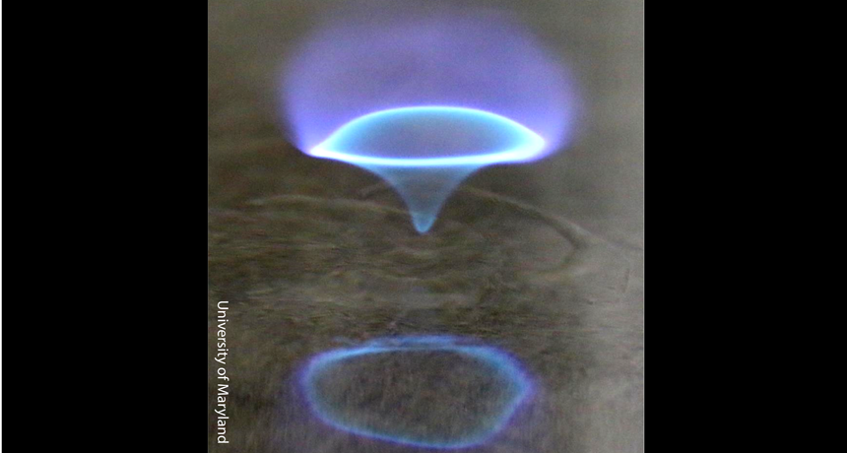

Researchers studying fire in the lab unexpectedly discovered a new type of fiery vortex. This swirling “blue whirl,” which burns exceptionally hot, creates very little soot.

UNIVERSITY OF MARYLAND

Researchers studying large swirls of fire in the lab have unexpectedly stumbled upon something new. It’s a small, blue, fiery vortex. This tiny tornado of flame burns incredibly hot and produces very little soot. If these fires can be created reliably — and controlled — they might offer a range of benefits. For instance, they might clean up oil spills in the water. And someday, they might even play a big part in clean combustion of fuel in devices such as furnaces or hot water heaters.
Explainer: How and why fires burn
Fires can be devastating. They also tend to be largely unpredictable. Those are just two reasons why many scientists study them. If researchers can figure out how fires behave, they might better predict where and how quickly blazes might spread. That could save lives as well as prevent property damage.

One of the more fascinating aspects to wildfires is the fiery whirlwinds that suddenly spring to life within what seems to be a normal wall of flame. These fire whirls — also known as “firenadoes” — can grow dozens of meters (yards) high, notes Elaine Oran. She is an aerospace scientist at the University of Maryland in College Park. Fire whirls are especially dangerous, she notes: They can lift small bits of burning material high into the air. From there, the material can fly off to distant sites, triggering new fires. So, these fiery whirls are a topic of intense study in Oran’s lab.
She and her teammates create the cyclones of fire in several ways. In one setup, they pump a liquid fuel onto the surface of a small pool of water. That fuel, called heptane (HEP-tayn), is a component of gasoline. When lit, this fuel evaporates, mixing with air.
One part of the team’s equipment guides air into an open-topped cylinder that surrounds the floating blob of fuel. This cylinder acts like a chimney. Incoming air creates a slowly swirling vortex inside the cylinder. As the burning vapors whirl and rise, they draw more air into the cylinder. This intensifies the swirling. Soon, instead of a roaring fire, there’s a whirling firenado. In the lab, these fiery cyclones can be around 1 meter (about 3 feet) tall. The researchers keep the firenado that size or smaller by controlling the fuel supply, Oran notes. If it grew much larger, they might quickly lose control over it.
Both the original blaze and the firenado that follows are loud. That’s a sign the airflow inside the fire is turbulent, or chaotic, says Oran. But during one experiment the team’s firenado shrank and evolved into a blue whirl of flame just a few centimeters (a couple of inches) tall. “We’ve never seen that before,” she notes. Certainly, she adds, “We didn’t expect it.”

That tiny blue whirl was very quiet. And that was one clue that the air flowing inside the flame was smooth, not turbulent. Its blue hue also signaled that this flame was much hotter than normal, maybe a couple of thousand degrees Celsius (a few thousand degrees Fahrenheit) rather than a few hundred. It also means combustion inside the whirl was not creating soot — the black, oily carbon that typically gives a flame a yellow hue.
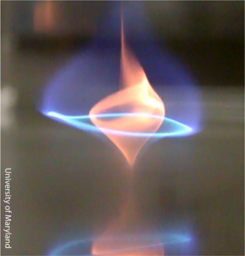
(Pictured Right) This clean-burning, centimeters-tall tornado of fire has been dubbed a “blue whirl.” Its developers say it might one day be harnessed to help clean up oil spills on the ocean’s surface.
University of Maryland

Besides burning hot and quiet, the little blue whirl was stable. “We found we could keep it going as long as we fed it fuel,” Oran says. “It’s a hungry little beast.” And when the fuel disappears, the flaming whirl dies out quietly.

After the flame was gone, the team tried to relight the water’s surface, where the fuel had been. But nothing happened. This signaled all of the fuel was gone. Any remnants had burned away, evaporated or sunk.

Floating oil spills cause huge problems, notes William Roberts. He’s an aerospace engineer who was not part of the research team. Roberts works at King Abdullah University of Science and Technology in Thuwal, Saudi Arabia. The oil from a spill can wash ashore to poison beaches and coat birds, he notes. Lighter gases or liquids in the oil can evaporate, polluting the air. The gunkier parts left behind will sink, fouling the ocean floor.

Plus, it’s really tough to recover spilled oil. Even where it can be collected, it usually can’t be used, Roberts notes. If people could find a way to create and control blue whirls, “it might be a way to burn spilled oil cleanly,” he says.

The team’s discovery shows the importance of doing lab studies of complicated phenomena such as fire, Roberts adds. “It’s that sort of looking that causes you to find things” like blue whirls, he observes. “This is something really cool. Now let’s figure out why it works and how we might be able to harness it.”

José Torero is an expert on fire safety at the University of Queensland in St. Lucia, Australia. Fires of all types, whether artificial or natural, are very complicated, he says. Within flames, all sorts of complex chemical reactions take place. There also are many ways for fires and streams of air to interact and influence each other. “There are fundamental physical processes going on in and around fires that we don’t understand,” he points out. “If we understood them better, we could better forecast how fires would behave.”

Until that day comes, people need to keep studying fires in the lab — and maybe stumbling across new and unexpected things like blue whirls.

Power Words
(Read through the article and highlight these words where you find them to help you understand them in the text)
aerospace A research field devoted to the study of Earth’s atmosphere and the space beyond or to aircraft that travel in the atmosphere and space.
carbon The chemical element having the atomic number 6. It is the physical basis of all life on Earth. Carbon exists freely as graphite and diamond. It is an important part of coal, limestone and petroleum, and is capable of self-bonding, chemically, to form an enormous number of chemically, biologically and commercially important molecules.
chemical A substance formed from two or more atoms that unite (become bonded together) in a fixed proportion and structure. For example, water is a chemical made of two hydrogen atoms bonded to one oxygen atom. Its chemical symbol is H 2 O. Chemical can also be an adjective that describes properties of materials that are the result of various reactions between different compounds.
chemical reaction A process that involves the rearrangement of the molecules or structure of a substance, as opposed to a change in physical form (as from a solid to a gas).
combustion (adj. combustible ) The process of burning.
cyclone A strong, rotating vortex, usually made of wind. Notable examples include a tornado or hurricane.
engineer A person who uses science to solve problems. As a verb, to engineer means to design a device, material or process that will solve some problem or unmet need.
evaporate To turn from liquid into vapor.
firenado A fiery tornado-like whirlwind that can suddenly develop within a wildfire.
fuel Any material that will release energy during a controlled chemical or nuclear reaction. Fossil fuels (coal, natural gas and petroleum) are a common type that liberate their energy through chemical reactions that take place when heated (usually to the point of burning).
fundamental Something that is basic or serves as the foundation for another thing or idea.
phenomena Events or developments that are surprising or unusual.
physical (adj.) A term for things that exist in the real world, as opposed to in memories or the imagination. It can also refer to properties of materials that are d ue to their size and non-chemical interactions (such as when one block slams with force into another).
Queensland One of the states that makes up the northeast corner of the country of Australia.
remnant Something that is leftover — from another piece of something, from another time or even some features from an earlier species.
soot Also known as black carbon particles, these are the residues of incompletely burned materials, from plastics, leaves and wood to coal, oil and other fossil fuels. The particles can be quite small — nanometers in diameter, and often oily. If inhaled, they can end up deep within the lung.
technology The application of scientific knowledge for practical purposes, especially in industry — or the devices, processes and systems that result from those efforts.
tornado A violently rotating column of air extending from the ground to a thunderstorm above.
turbulent (n. turbulence) An adjective for the unpredictable fluctuation of a fluid (including air) in which its velocity varies irregularly instead of maintaining a steady or calm flow.
vapors Fumes released when a liquid transforms to a gas, usually as a result of heating.
vortex (plural: vortices) A swirling whirlpool of some liquid or gas. Tornadoes are vortices, and so are the tornado-like swirls inside a glass of tea that’s been stirred with a spoon. Smoke rings are donut-shaped vortices.

