STEM Friday # 5
Technology in the Classroom

Read the first page of the article and then PICK A SIDE--- Yes, Technology or No, No Tech!

With your group you will create a brochure either promoting technology in the classroom or arguing against it.

Your brochure must be:
- tri-fold
- all sides must have information or graphics on them
- full color (all pages must have color)
- at least 3-4 graphics related to your argument
- a promotion of your argument that could be presented to Mr. Smiley & Mr. Perkins for our school
  - Your argument must be backed up with at least 2 (IPC) / 3 (Chem) citations from the text

Create a pocket in your binder to keep your article. One person should turn in the brochure by putting it in their pocket. Everyone else needs to write ON THEIR POCKET who has the brochure.
Does Technology Belong in Classroom Instruction?
Some say it broadens horizons, others that it can’t teach children how to think

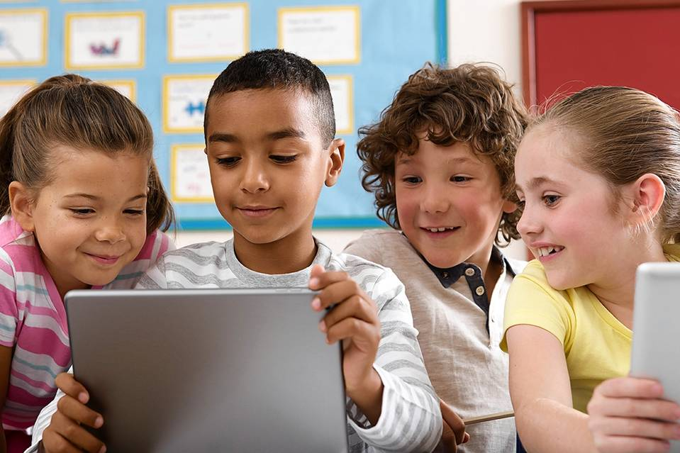

There’s no disputing that digital technology plays a major role in education. Millions of students are using personal computers, tablets and even smartphones to research and complete assignments, communicate with each other and with teachers about their courses and sometimes collaborate on school projects.
But that still leaves plenty of room for disagreement on whether technology should play a major role in the classroom itself—that is, whether teachers should rely on digital tools for a significant portion of their classroom instruction.
On one level, the question boils down to how best to take advantage of classroom time.
Some see a great opportunity for teachers to expand their students’ horizons by drawing on the vast resources of the Internet to supplement classroom lectures and discussion. And computers can help individualize instruction, which some people see as a way to help ensure that every student is getting the most out of being in school, without either being held back by the slower pace of others in the class or getting lost as the class zooms ahead.
But others think there’s a danger that using technology in the classroom diminishes the teacher’s role. The Internet is a great source of information, these people say, but teachers should use classroom time to focus on teaching their students how to process that information by reflecting deliberately on how it changes their view of the world.
Based on the information above, Pick a Side!!!
YES: New Tools Let Students Learn More, and More Deeply
By Lisa Nielsen
To thrive in a digital world, students need to learn how to sort through unlimited information sources. Schools need to arm them with the skepticism and critical thinking they need to do that. And that requires that schools embrace digital devices as learning tools.

Using technology, students are still learning to think for themselves and along with others, but they’re also learning in ways they couldn’t before.
In English class, students are no longer just handing work in to an audience of one: the teacher. They are publishing work for the world to see on digital platforms. In science classrooms, technology allows students to do virtual dissections and gain access to world-class resources and experts, like astronauts from the National Aeronautics and Space Administration who participate in the Teaching From Space program. In math class, all students no longer have to be working on the same problem at the same time. Instead, they can view individually appropriate videos, which they can re-watch, slow down or fast forward, and take assessments to show what they know, when they are ready.

Going further
Using simple and free tools, with the guidance of teachers to ensure they are on task and interacting safely, students can do more than old-school information consumption and regurgitation. A traditional social-studies class studying their community might read the textbook, listen to a lecture, discuss, and answer questions at the end of the chapter. In a “bring your own device” class, students can access primary sources such as public records, photos, journals, speech recordings or newspaper clippings—with guidance from teachers on searching for images and on copyright laws and permissions. They can see how the community has changed over time with any number of free online tools or by using videoconferencing to interview residents in real time.
These students also are able to use what they’ve learned in creative new ways. For example, they might make interactive maps or photos. Click on a place in the community, and it comes to life. And they can publish their work on social-media sites such as blogs, Facebook pages and Twitter and get relevant, real-world feedback.
There’s more deep thought happening here than there is without technology, not less. It’s faster-paced, but that’s the world these students are preparing for. Which way would you prefer your child to learn?

Teachers in charge
Using digital devices in the classroom doesn’t mean students are texting friends, chatting on the phone in class or using devices to cheat. Just as they were able to manage a traditional classroom where students might be passing notes, staring out the window or looking at their neighbor’s answers on a test, teachers are finding the best ways to manage students using digital devices.
Indeed, teachers are incorporating students’ love of texting into instruction. They are using texting tools to invite students to have conversations about what they learned in class that day and to post their reflections on student-response platforms. With these techniques, all voices are captured, and class time is spent discussing student input rather than collecting it. Teachers who are tapping into students’ love of texting are helping their students increase their literacy skills, too. Numerous studies have shown that the more children text, the more literate they become.
Of course, proper training and support for teachers from school administrators are essential for technology to work in the classroom.
We know that any connected device provides access to information, resources and experts far beyond what a school building could ever offer students. Why would we limit learning possibilities by not fully taking advantage of that?
Ms. Nielsen is director of digital engagement and professional learning for the New York City Department of Education. She is the author of The Innovative Educator blog and books including “Teaching Generation Text.” She can be reached at reports@wsj.com,

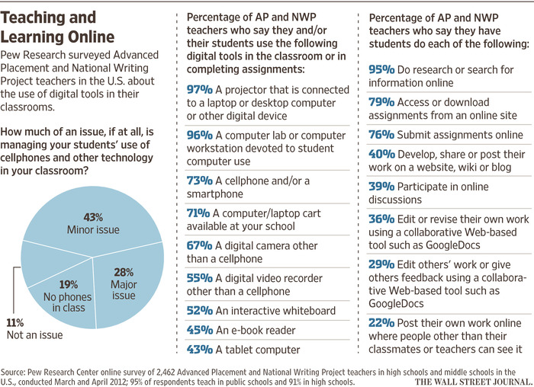

NO: Classrooms Must Be a Place of Focus and Mental Stillness
By José Antonio Bowen

Technology is changing education, but the most important interaction in the classroom will remain the face-to-face interaction between teachers and students. This personal interaction has been at the heart of teaching students how to think since the time of Socrates, and technology—in the classroom—often interferes with that education, rather than enhancing it.
There is no question that technology has increased students’ access to knowledge. But that has only amplified the importance of discernment, analysis, and skepticism about all of this new content—in other words, critical thinking. Finding relevant and accurate currents in an ocean of often useless or misleading Internet content is a persistent problem.
Bringing technology into the classroom doesn’t solve that problem; it only brings it into the classroom. In fact, it is a distraction from the real solution: teachers taking the time to help students learn to process and think. In doing so, teachers help students see how the same information can be useful or useless, depending on the context or the problem they wish to solve. The Internet has fostered the disaggregation of information. Teachers help students integrate.
The hard part is not learning new facts, but rather seeing how those facts alter what we already know. Facts students learn on their phones can help them see the world in a new way, but only because they were taught how to reflect on what they have learned.

Slow down
Civilization and democracy need contemplation, mindfulness and focus. Tablets and computers are designed to be interactive, and sidetrack us from deeper thinking. The distractions of a student’s iPad are virtually irresistible. Teaching is hard enough without those distractions, and classrooms should be a sanctuary of focus. Children need a place to learn mental stillness, deliberation, critical thinking and human empathy.
Slow thinking is harder to learn when computers answer questions immediately. We can teach students a better way to learn by telling them: Close your iPad and think about the new information you’ve absorbed, write the key argument in your own words; swap with your neighbor, write a rebuttal, discuss and finally reconsider your original assumptions about this topic.
The most important thing a teacher does in the classroom is to be an intellectual role model. Great teachers show how to pause and ponder new questions. Teachers demonstrate what smart people do: They ask better questions; they analyze; and mostly, they stop and think. For our democracy to thrive, we need classrooms full of teachers who can say, “That is a great question. You have changed my mind.”

Invest at home
I am not advocating a complete ban on technology any more than we should ban all books or other educational resources. Digital devices provide many benefits; however, access to more knowledge hasn't made us smarter. In the same way that more TV channels haven't made us better informed and more exercise equipment hasn’t made us fitter, we don’t need more technology in the classroom.
If we are going to go to the trouble of assembling people face-to-face, then we need to leverage the distinct advantages of personal contact. Children would be best served by equal access to a laptop outside the classroom (bridging this digital divide is a very real educational problem), and then the emphasis when assembled in classrooms can be on reflection, teamwork, play and thinking.
In classrooms, students mostly need integrators, motivators, cognitive coaches and intellectual role models, who can show students what it means to be smart. Computers can teach us much about human knowledge, but they can’t teach us how to be human. Our phones are not really smart, and they can’t teach us how to be smart.

