Lab Safety Worksheet

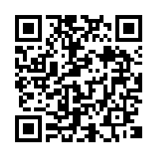
- Why is it important to tie back your hair?

- What 2 things are nonnegotiable in the science lab?
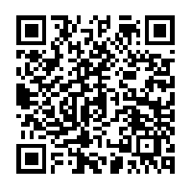

- What horseplay is happening and why is horseplay not allowed in the science lab?
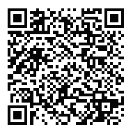

- Why is it not a good idea to wear baggie clothing in the science lab?

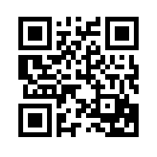
- Why should you not eat, drink or apply cosmetics in the science lab?

- What should you do when smelling a chemical in a science lab?
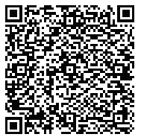

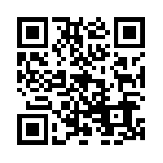
- When do you use a fumehood? (hint: look in tan area)

- What should you add to what between acid and water?

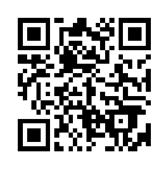
- What should you use to pick up broken glass?

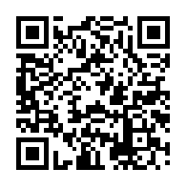
- Where do you place the open end of a test tube being heated?

- How long do you stay in the eye wash if a chemical gets into your eye?
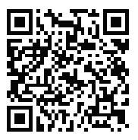

- Why do you not put your leftover back into the stock bottle?
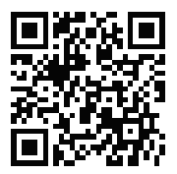

- Why would you want to check glassware, especially before heating, for cracks?
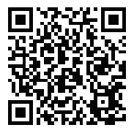

14. How do you know where to dispose of products from the lab?

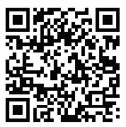

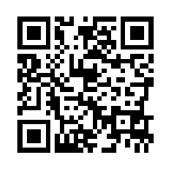
15. What does this chemical symbol mean?

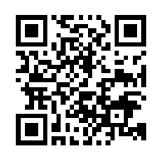
16. What does this chemical symbol mean?

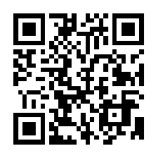
17. What does this chemical symbol mean?

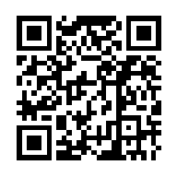
18. What does this chemical symbol mean?

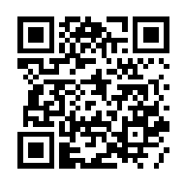
19. What does this chemical symbol mean?

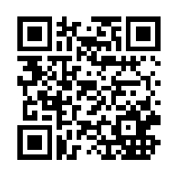
20. What does this chemical symbol mean?

