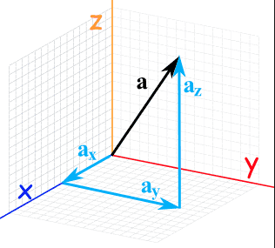
Honor Physics
Project of the Week
1/4 – 1/8

Your project this week is to complete the following:

- Write a 1 page paper (single spaced) over the given topic
- Your paper must be typed
- Font: Times New Roman, 12 pt
- You must submit your paper by no later than 2:05 (end of class) on Friday 1/8 to my email [mpurvis@snyderisd.net]
- You will be graded using the rubric provided

Your topic:

In what professions are vectors used typically and why does it matter to you? How could they be used in your everyday life?

