Physics Conversions Brush Up

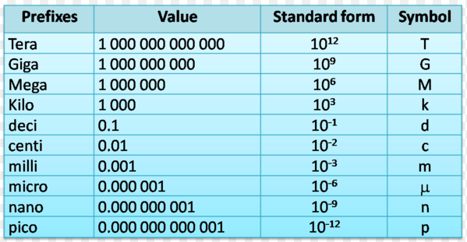
- Start with knowing the common prefixes and what they stand for

Base Unit

- Remember that you must begin with canceling the unit you have and then introducing a new unit
  - If you begin with km on top it must go on the bottom to cancel
  - ________5____km X _________1000m________ = 5000m
1 km

- If you begin with a number that has two units (ex: m/s or km/h) choose one unit to convert, get it to the correct units, and then begin with the other unit as if you were starting from the beginning
  - ______5_____km X ____1000____m X _____1____hr X ____1___min = 1.39 m/s
hr 1 km 60 min 60 sec

- Remember that you cannot always just jump straight from one unit to another. If you are moving from a very large unit to a very small unit you move through the base unit (meters, grams, minutes, etc). Always convert back to the base unit and then convert to the next unit.
- Practice Problems
  - 14m/s to km/hr
  - 540μm to m
  - 1.3 Mm to cm
  - 105 cm/s to km/min

