Matter & Separation Techniques
Notes Outline

____________________________

_________________________________ ____________________________

___________________ ____________________ ____________________ __________________
Examples:

Separation Techniques

- ___________________________
- Start with a _________________________
- Example: _____________________ mixed with _______________________
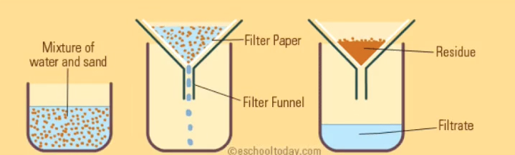
- Label the blanks in the picture:
- the liquid that passes through the filter paper is called the __________________________
- the substance that does not pass through the filter paper is called ________________________

- __________________________________________
- Water wants to travel ______________
- Separates _____________ by allowing it to travel ____________ the paper
- In the space provided below draw a picture of what chromatography looks like

- _______________________________________
- Start by adding _____________________
- We are still starting with a ________________________
- Add _______________ until the part of the mixture with a lower boiling point becomes a ______________
- Heated _________________ travels down the tube until it encounters ___________________ water
- The gas then becomes a _________________ and drips out the end of the tube into a new container

- _____________________________________
- Similar to ___________________________ because __________________ is still being applied
- In this method a different change occurs and instead of forming a gas or a liquid a ______________________ is formed in the top dish

- ___________________________________
- aka By _________________ or Using _______________________

Conclusion
List the 5 Methods of Separation Below:
1.

2.

3.

4.

5.

Properties & Changes
Notes Outline

- A property is a ___________________ or characteristic that an object ____________________ has
- Examples:
  - ___________________ , ______________________, ___________________, ___________________
- A change means that some __________________________ has occurred from start to end

- A physical property is something that does ______________ make something new.
- Examples:
- A chemical property is something that causes a ____________________
- Examples:
*** Remember that properties are just the ____________________ or ________________________ and that no __________________ has occurred yet***
Types of Properties
- There are 2 types of properties: ___________________________ & __________________________
- ___________________________ properties (_______)
  - The _______________________ of substance does _______________ matter
  - Ex:
- __________________________ properties (________)
  - The _______________________ of substance _________________ matter
  - Ex:

Properties Practice
- Label the following as either intensive (I) or extensive (E):
- Color
- Density
- Mass
- pH
- Volume
- Flammability
Physical & Chemical Changes

- With a __________________ change NO new ___________________ is formed
- Example:

- With a __________________ change a new substance ____________ formed
- The _______________ point and the ____________ point are different
- Example:

