History of the Atom

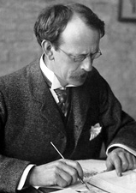

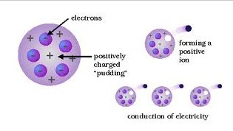 J.J. Thomson—Identified the negatively charged electron in the cathode ray tube in 1897. He deduced that the electron was a component of all matter and calculated the charge to mass ratio for the electron. Thomson is proposed the “plum pudding” model of the atom.

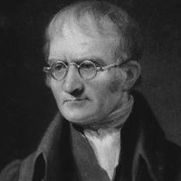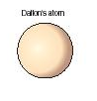John Dalton—Proposed the Law of Multiple Proportions. This law led directly to the proposal of the Atomic Theory in 1803.

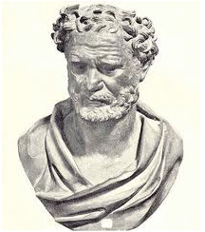 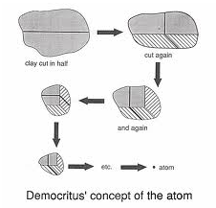 Democritus—First proposed the existence of an ultimate particle. Used the word “atomos” to describe this particle in 460-370 BC.

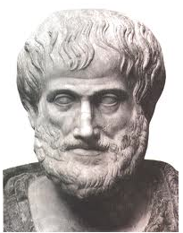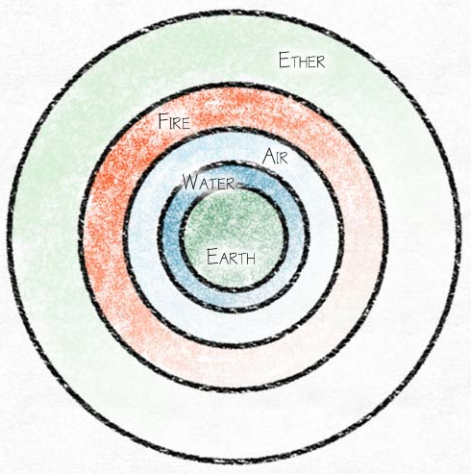 Aristotle—Felt that regardless of the nuber of times you cut a form of matter in half, you would always have a smaller piece of that matter. This view held sway for 2000 years primarily because Aristotle was the tutor of Alexander the Great in 384-322 BC.

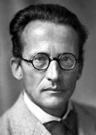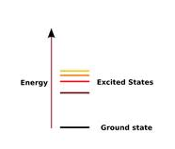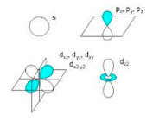 Erwin Schrodinger—developed the equation which is used today to understand atoms and molecules-the Schrodinger Equation (1926). He said all energies are quantized and the orbitals, associated with each energy, determine where they are located.

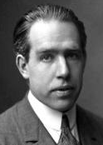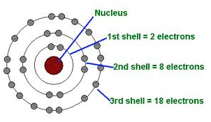 Niels Bohr—in 1913 applies quantum theory to Rutherford’s atomic structure by assuming that electrons travel in stationary orbits defined by their angular momentum. This led to the calculation of possible energy levels for these orbits and the postulation that the emission of light occurs when an electron moves into a lower energy orbit.

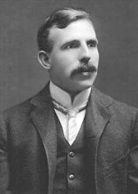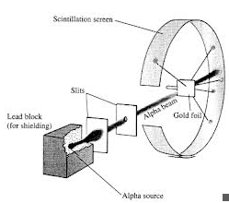 Ernst Rutherford—proposed the nuclear atom as the result of the gold-foil experiment in 1911. Rutherford proposed that all of the positive charge and all of the mass of the atom occupied a small volume at the center of the atom and that most of the volume of the atom was empty space occupied by the electrons.

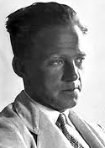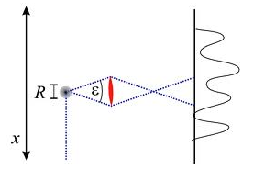 Werner Heisenberg—Classical physics had always assumed that precise location and velocity of objects was always possible. Heisenberg, however discovered in 1923 that this was not necessarily the case at the atomic level. In particular, he stated that the act of observation interfered with the location and velocity of small particles such as electrons.

