Electron Configuration Notes

- The arrangement of electrons in the atom is called the electron configuration

- Each energy level has sublevels:

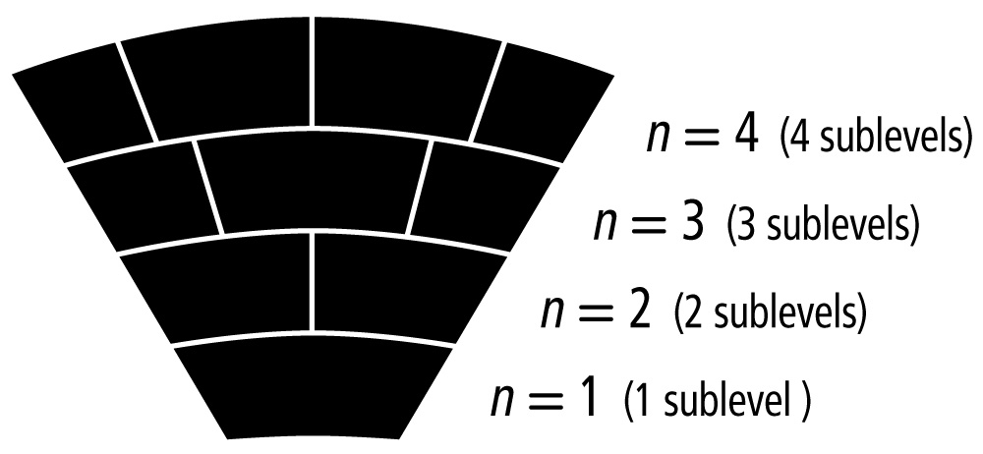

- These are the energy levels and sublevels attached to each:
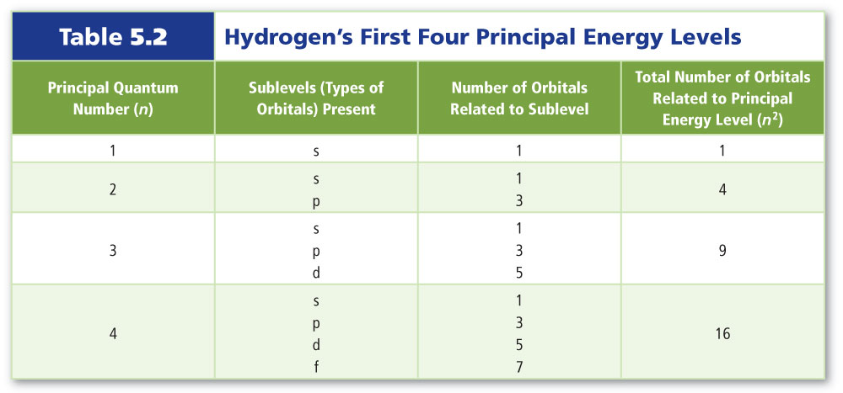

- The order to filling up the energy levels with sublevels included:
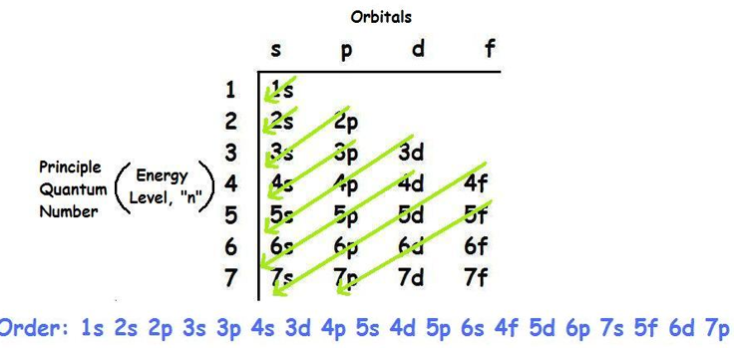

- The positions on the periodic table:
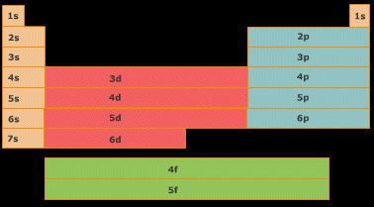

Rules to follow

The aufbau principle states that each electron occupies the lowest energy orbital available.

Hund’s rule states that single electrons with the same spin must occupy each equal-energy orbital before additional electrons with opposite spins can occupy the same energy level orbitals.

The Pauli exclusion principle states that a maximum of two electrons can occupy a single orbital, but only if the electrons have opposite spins.

Electron Configuration for Iron (Fe)

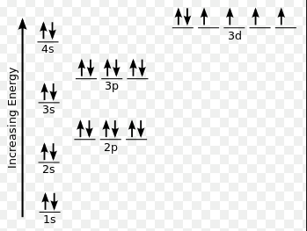
1s²2s²2p⁶3s²3p⁶4s²3d⁶

Noble Gas Notation (shortcut)

Noble gas notation uses noble gas symbols in brackets to shorten inner electron configurations of other elements.

For iron above would be:

[Ar]4s²3d⁶

