Drawing Ionic Bonds

Remember: Ionic bonds form between POSITIVE IONS and NEGATIVE IONS. Ionic bonding is when one of the atoms is donating an electron(s) (the cation) and one of atoms is accepting an electron(s) (the anion). The electrons are not shared, the anion gains an electron(s) to achieve a full valence and the cation loses an electron(s) to achieve a full valence.

Diagram the ionic bonding process from neutral atoms to ions showing the valence electrons and indicating with arrows the direction in which the electrons are going. Take a picture of your drawing and insert it in the proper location.

Example: sodium nitride (Na₃N)
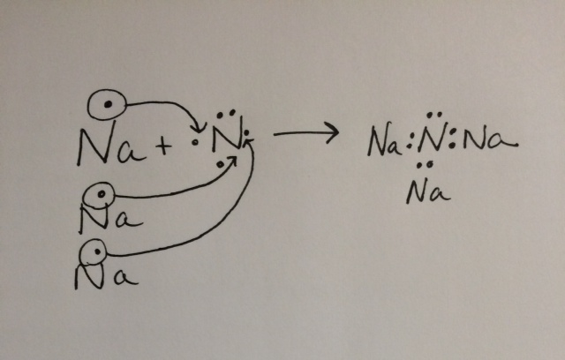

- sodium chloride (NaCl)

- potassium fluoride (KF)

- barium oxide (BaO)

- sodium oxide (Na₂O)

- magnesium chloride (MgCl₂)

- aluminum chloride (AlCl₃)

- calcium chloride (CaCl₂)

- rubidium oxide (Rb₂O)

