Drawing Covalent Bonds Practice
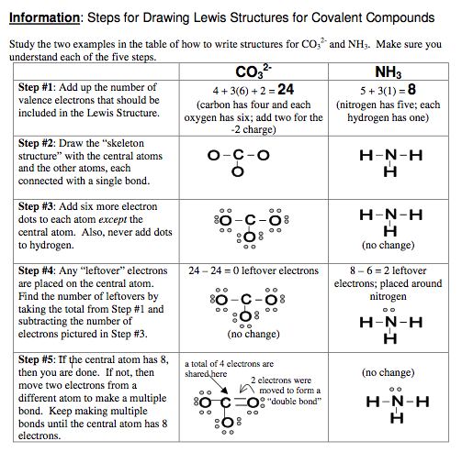
Background info:
When atoms of nonmetals bond to each other they share valence electrons and form a covalent bond. When atoms bond they usually have to rearrange their electrons from the positions we pictured in the single atom. The goal is for every atom to have eight electrons around it except for hydrogen which has only two electrons. Hydrogen only forms one single bond; other atoms can form up to four single bonds. When you draw a dot diagram for a molecule you start with the atom that is only in the formula once—it will be in the center of the molecule with the other atoms arranged around it. If there are only two atoms it doesn’t matter where you start. Draw Lewis dot diagrams for the following molecules.

HINT: Carbon, nitrogen, and sulfur are usually the central atom(s) (in the center) surrounded by terminal atoms (surrounding central). Carbon is always a central and hydrogen is always a terminal. When in doubt, put the any single atom in the middle, surrounding it with the element that contains more than one atom.

Using the notes and information above draw and take a picture of the covalent lewis structures and upload them below:

Single Covalent Bond Example: nitrogen triiodide (NI₃)

- carbon tetrabromide (CBr₄)

- dihydrogen monosulfide (H₂O)

- dihydrogen monoselenide (H₂Se)

- phosphorus triodide (PI₃)

Double Covalent Bond Example: carbon dioxide (CO₂)

- oxygen (O₂)

- ethene (C₂H₄) (*C’s are always central and they will link together)

Triple Covalent Bond Example: nitrogen (N₂)

- ethyne (C₂H₂) (remember C's are always central atoms)

- hydrogen cyanide (HCN) (*the carbon is in the middle with the other two attached to it)

Now you are going to draw electron dot diagrams for the following polyatomic ions. Remember that even though they are ions the atoms are held together inside the ion with covalent bonds. Negative ions have gained electrons, you must include these in the structure. Positive ions have lost electrons, you must delete these from the structure,

Polyatomic Molecule Ion Example: ammonium ion [NH₄]⁺¹

- hydroxide ion [OH]⁻¹

