Conversions Notes Outline
(A Dimensional Analysis How To…)

Follow the following steps in order to convert from one unit of measurement to another:
- Read the problem (some may be word problems) and analyze to determine what unit you are starting out with.
- Write your starting number/units down as “over 1” or “divided by 1”.
  - Ex: You are starting with 5cm so you write
5 cm x
1
- Now read the problem and analyze what units you are trying to convert to. Write down where you are going from and where you are going to so you don’t forget.
  - Ex: 5centimeters (cm) to meters (m)
- Now set up your conversion outline. Always start with your starting number & units over 1 and then put a multiply sign and draw a line
  - Ex: You are starting with 5cm so you write
5 cm x _________________
1
- Now you must eliminate the units you are starting with and introduce a new unit.
  - If you start with a unit on the top then that same unit must go on the bottom to cancel.
    - 5 cm x _________________
      - cm
  - Now that you have canceled your beginning unit you must introduce a new unit.
    - 5 cm x ____________m__
      - cm
- If you are to the desired units you may end your set up there. If you need to go further draw another line and repeat step 5.
- Now you can fill in the correct numbers to convert. Utilize the given conversion factors or ones you may need to know from memory fill in the missing spaces in your conversion set up.
  - Always put a “1” with the bigger unit!
    - Meters is bigger and thus a “1” will go on top with meters.
    - The prefix “centi-” means 100 so a “100” will go on the bottom.
    - 5 cm x _______1_____m__
      - 100 cm
- Solve! Now you can solve your conversion.
  - Multiply across the entire top & divide across the entire bottom.
  - Don’t forget to include your parenthesis!
    - ( 5 x 1 ) = 0.05meters
( 1 x 100)
Conversion Factors & Prefixes

Here is a list of conversion factors that will be very useful in this class.; some you will be required to memorize, all others will be provided.

Prefixes
- You will be required to memorize the following prefixes for all of your science classes (and probably some math classes)
- Memorize the following!
  - Kilo = 1000
    - Ex: 1 kg = 1000g
  - Centi = 100
    - Ex: 1 m = 100cm
  - Milli = 1000
    - Ex: 1L = 1000mL
- Keep in mind that the “1” ALWAYS goes with the bigger number!!!

Conversion Factors
- Here are some helpful conversion factors that will be provided to you to solve problems.
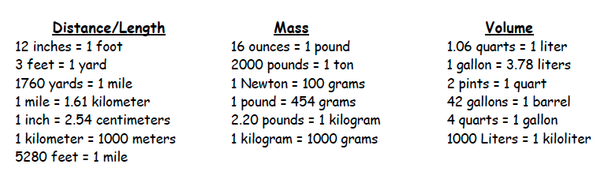

- You may also be asked to convert time. You should know time conversions already but if you are having trouble with them come see me.

Let’s Convert!
Practice Problems

Directions: On another sheet of paper solve the following problems using the dimensional analysis method we just learned.
