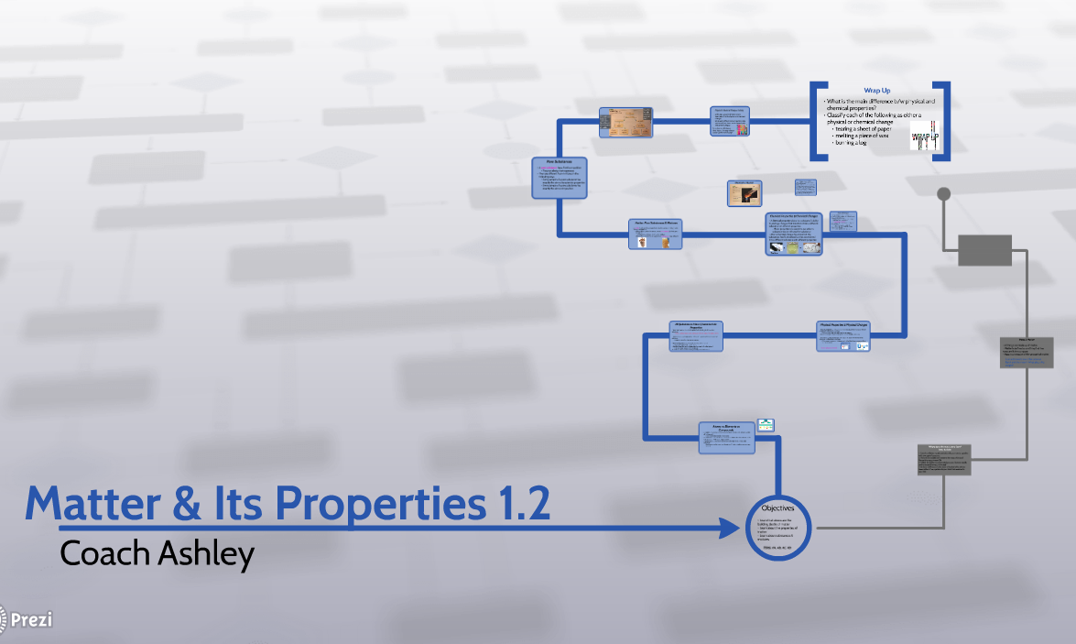 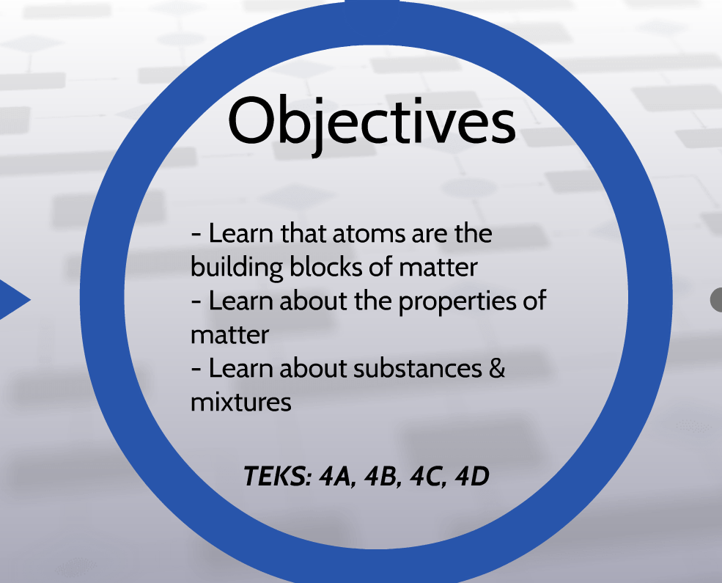

Ch 2

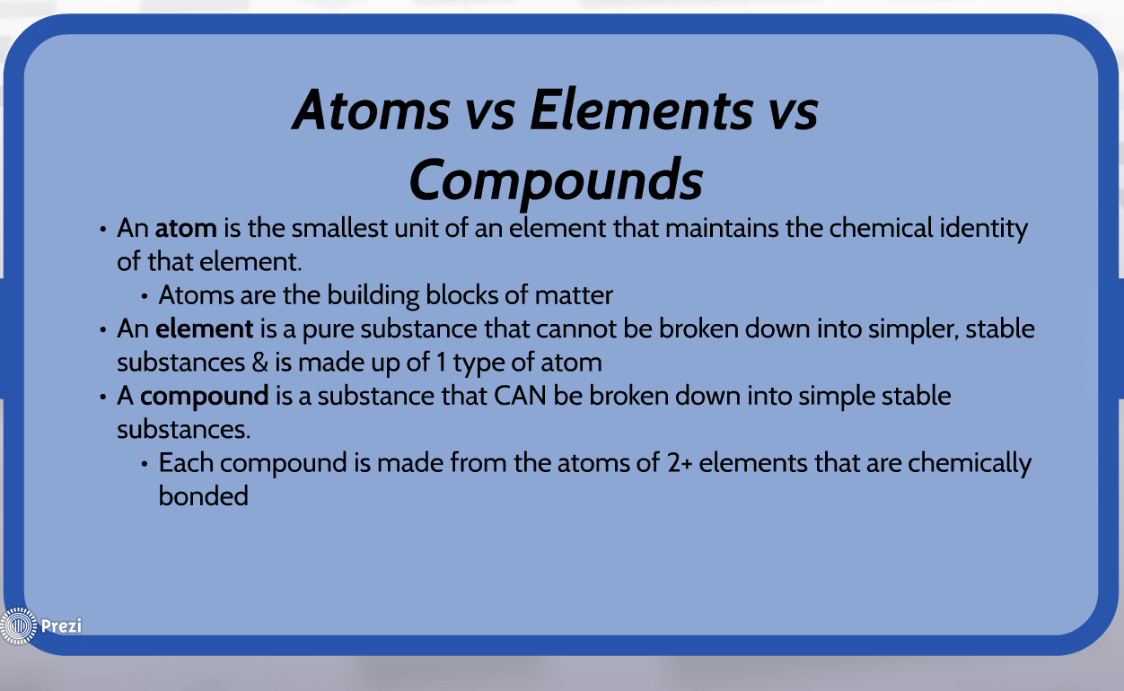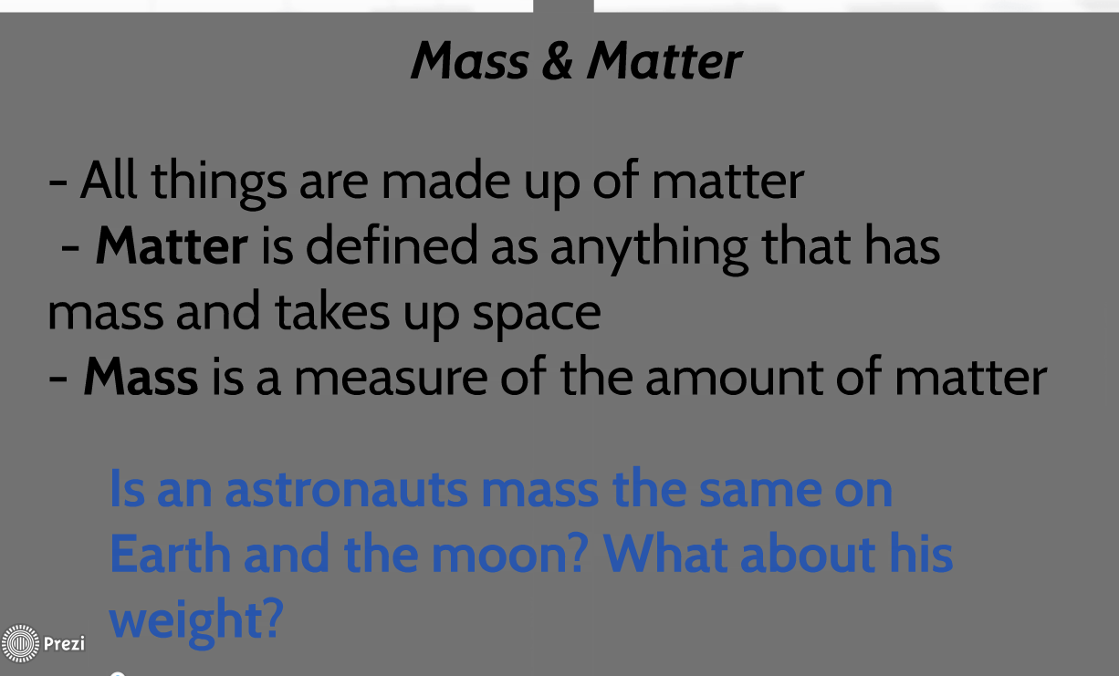

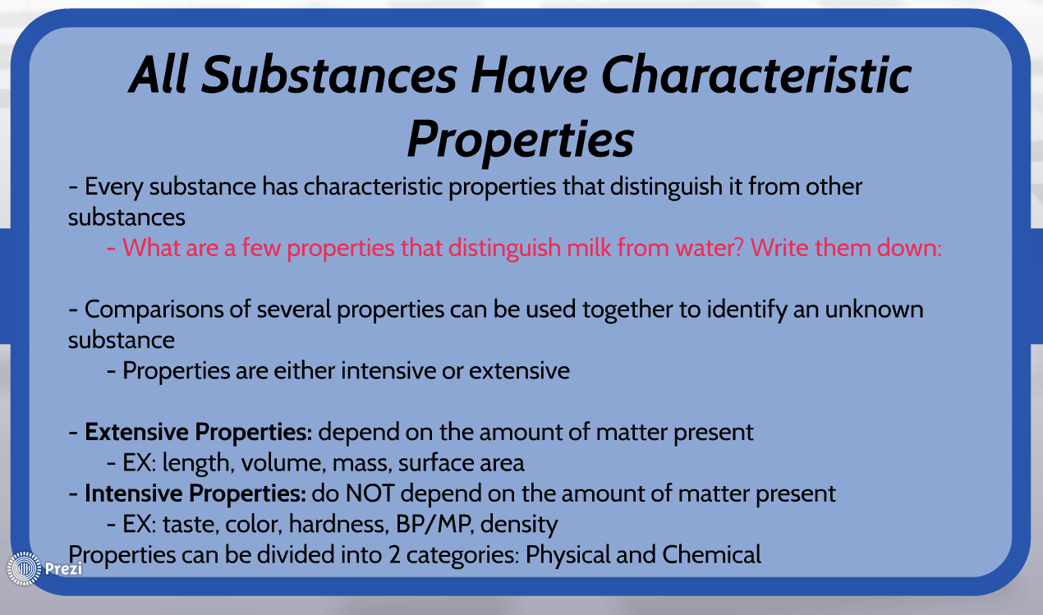

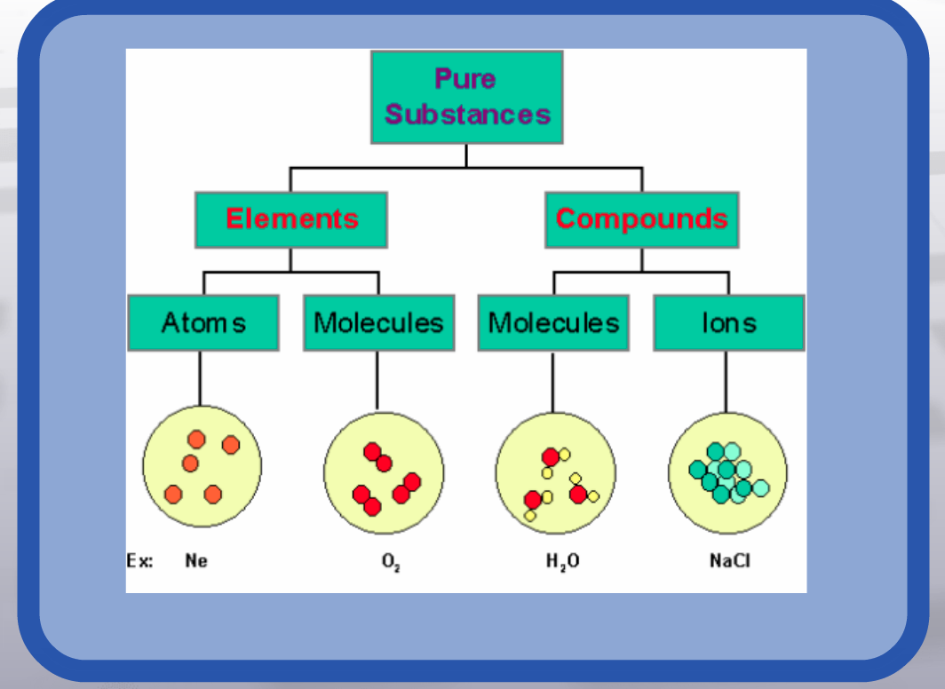

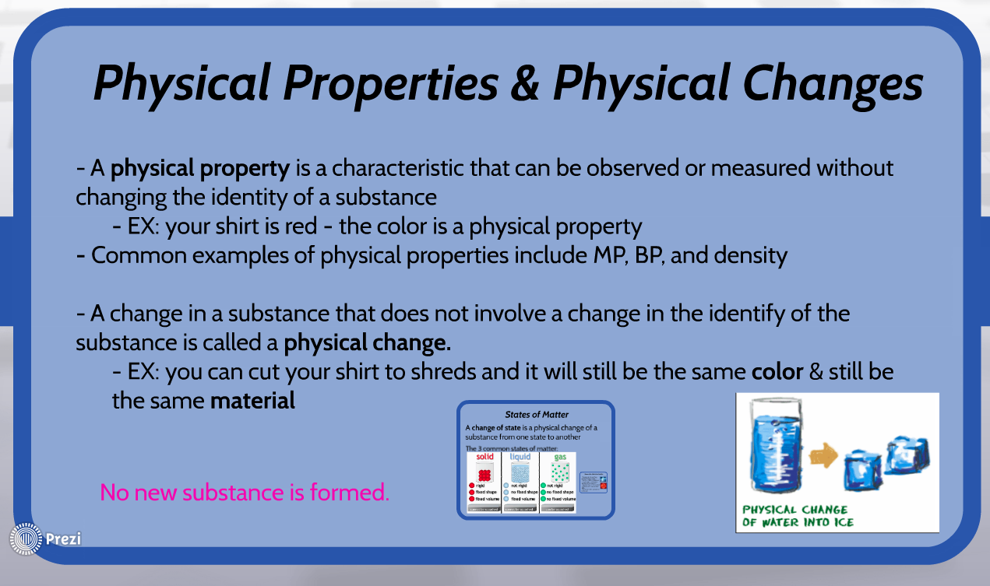 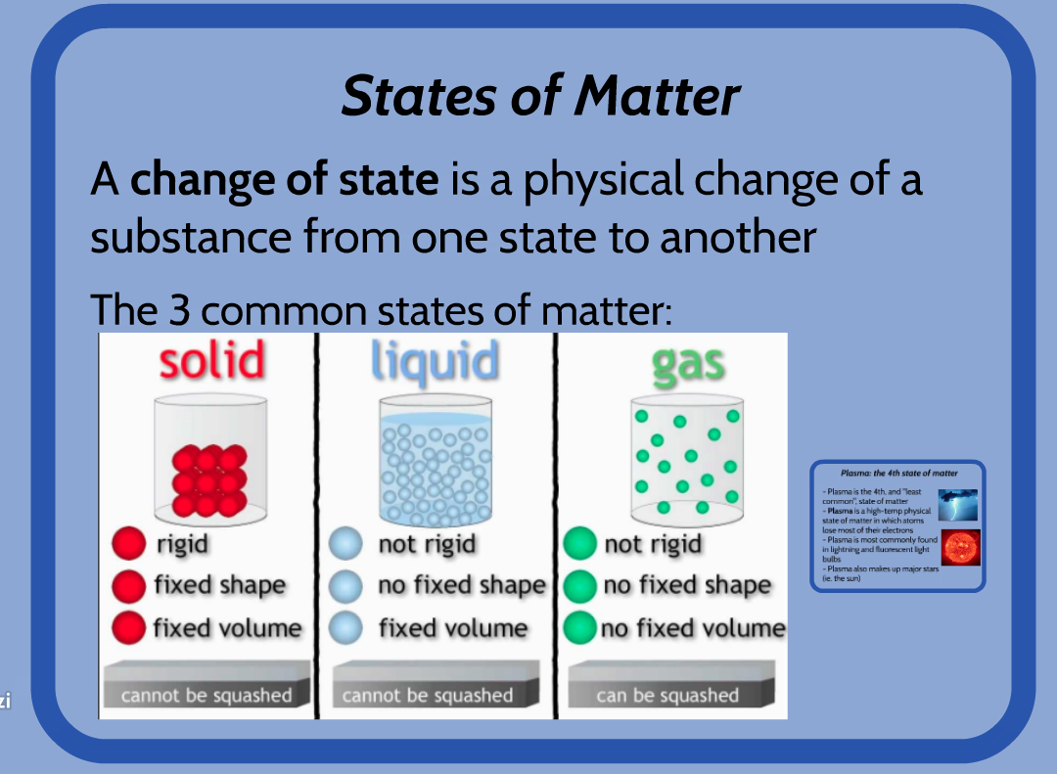

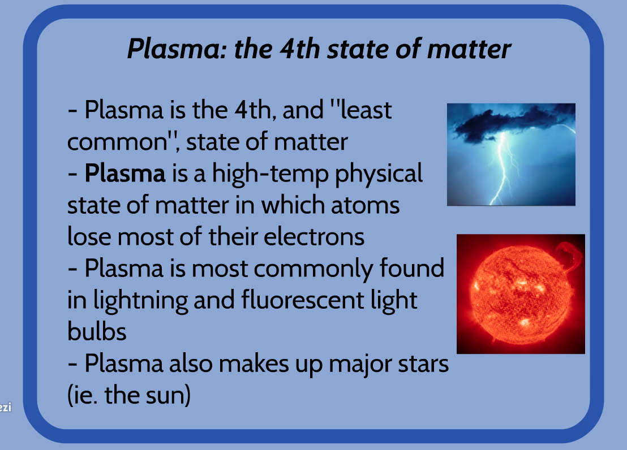 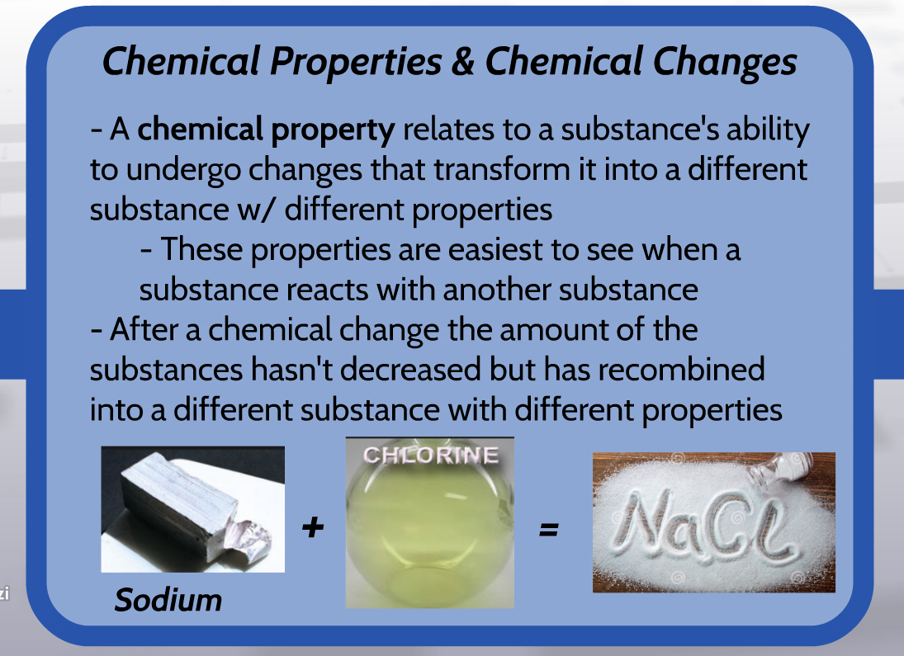

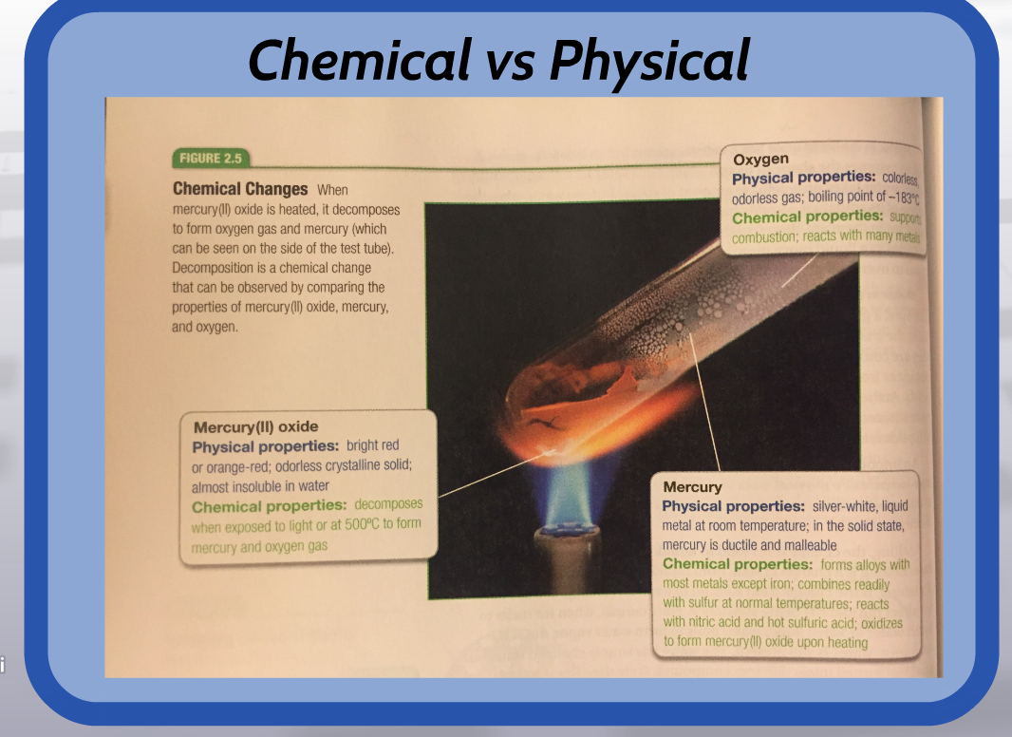

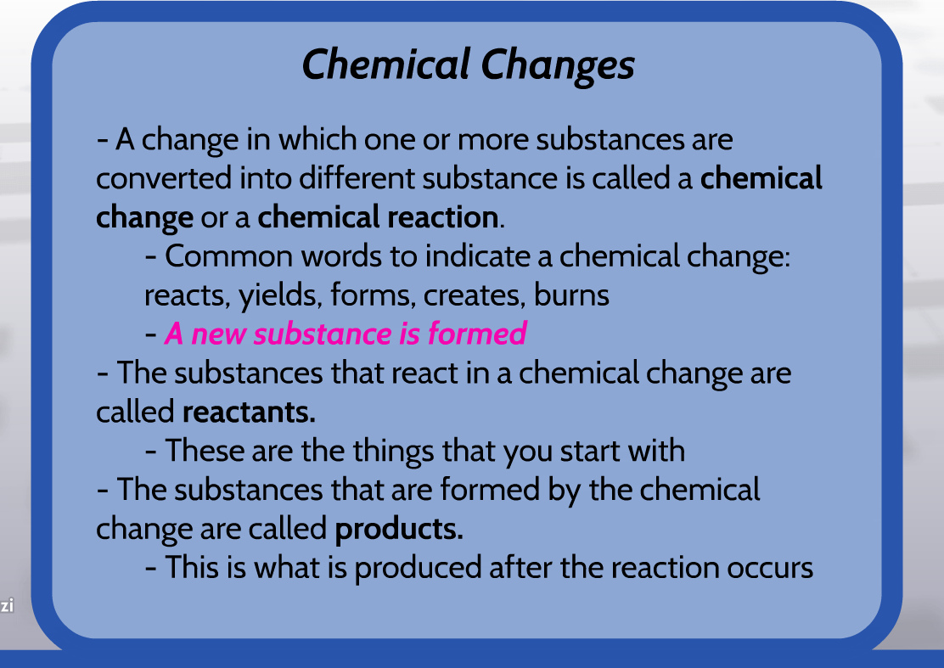

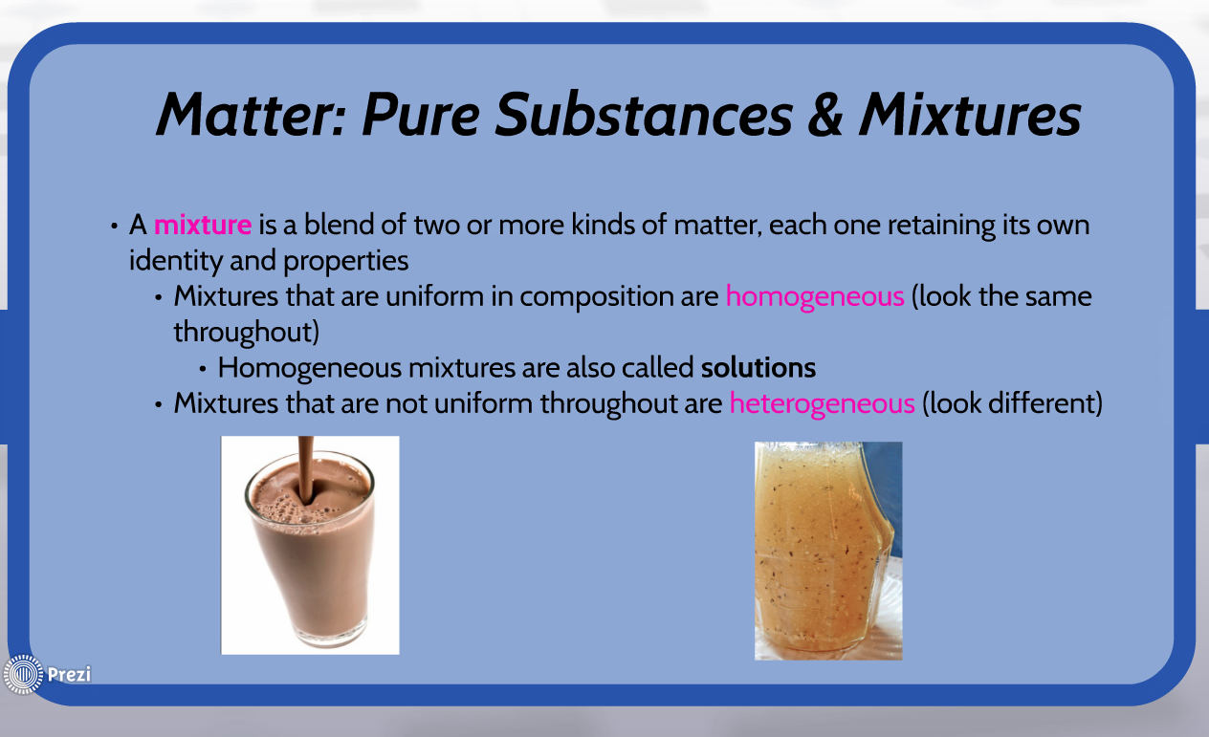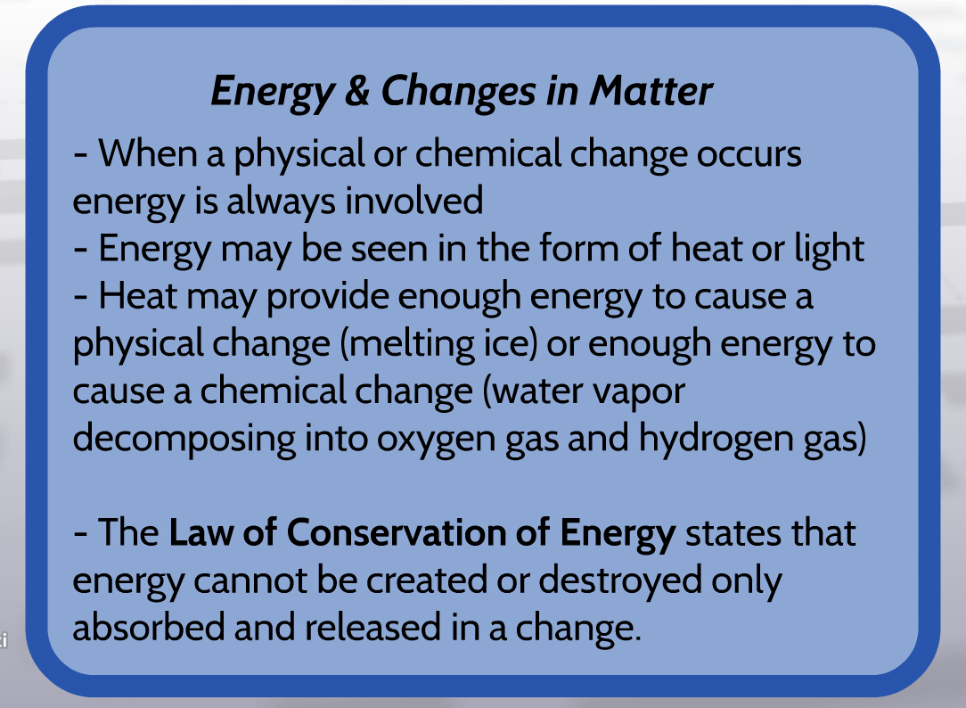

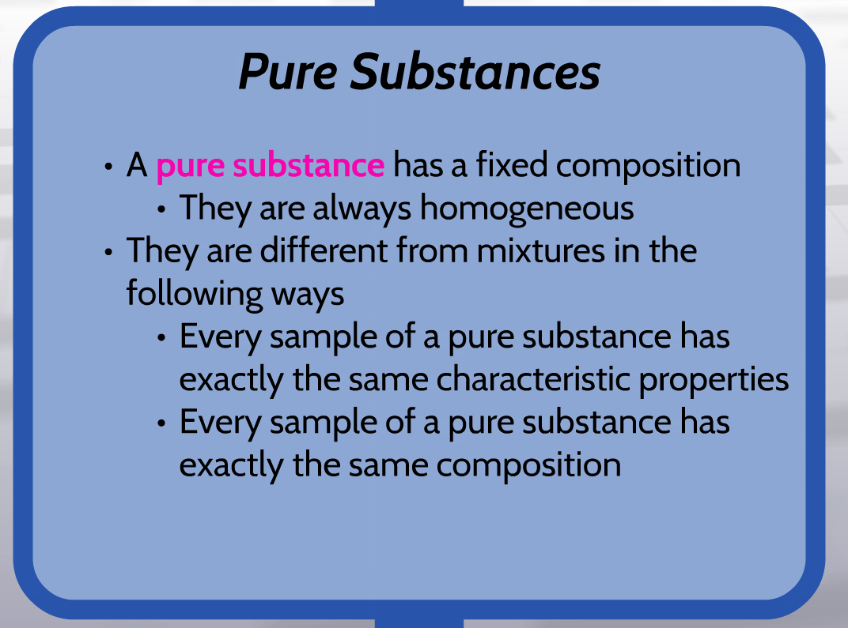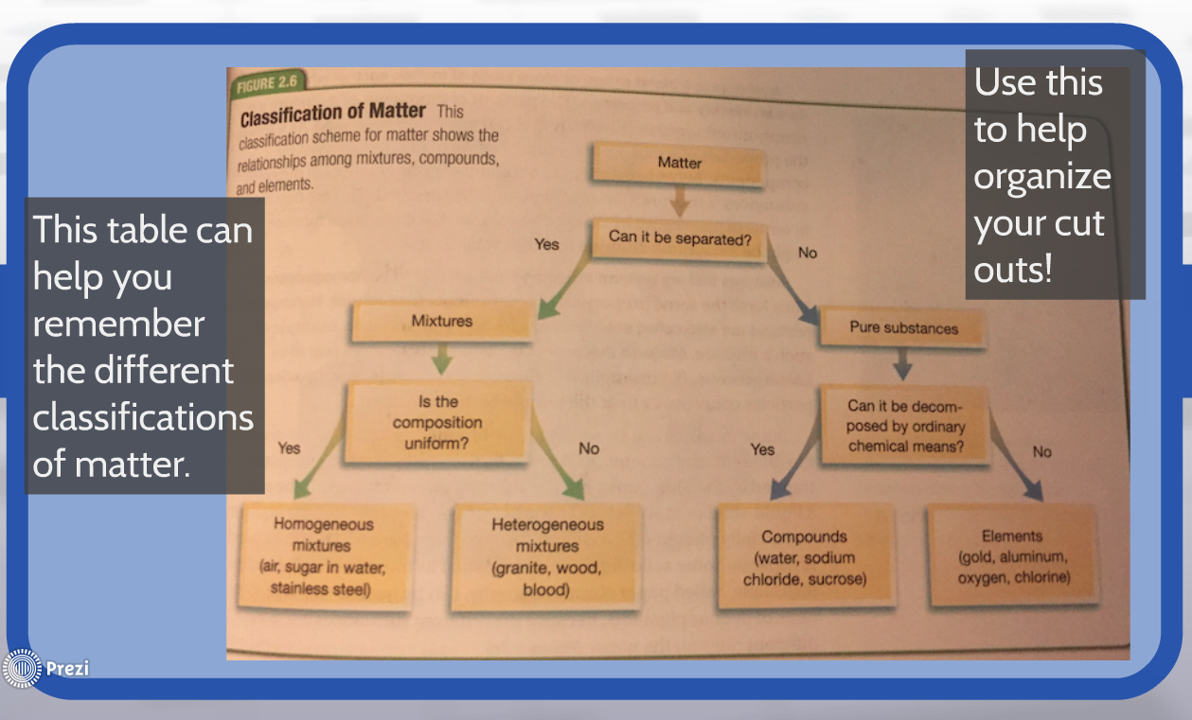

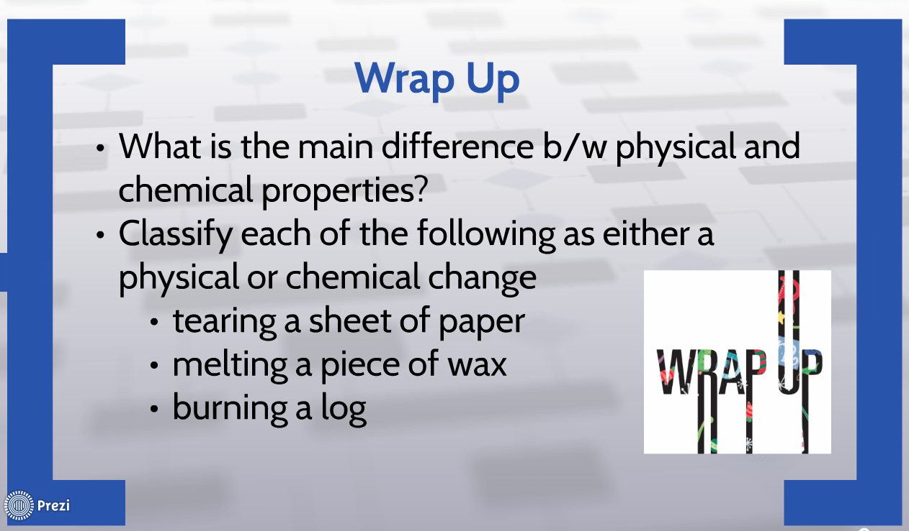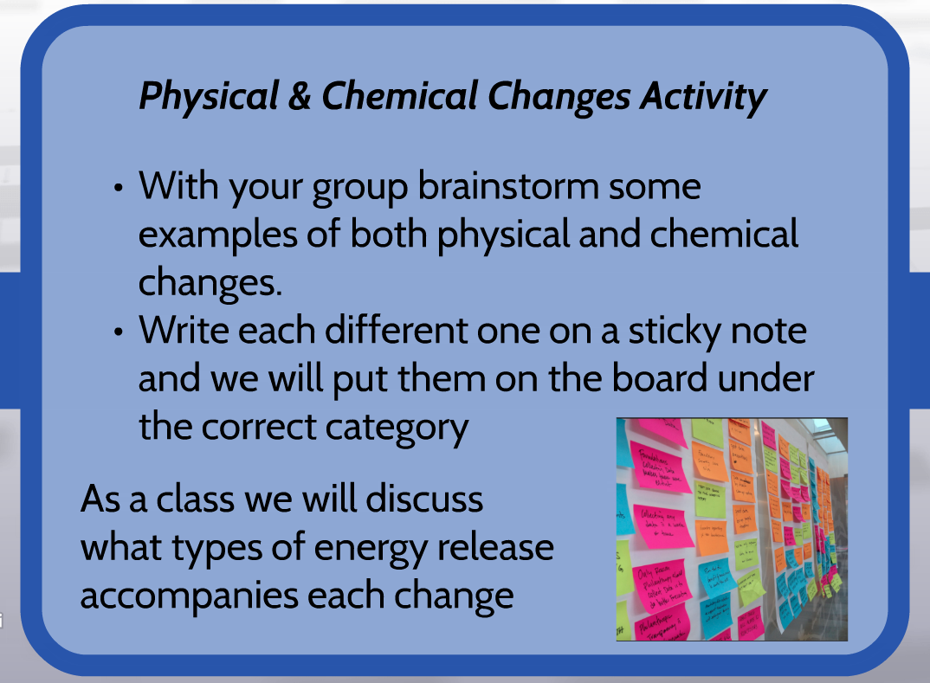

Chapter 2 Notes Activity

* Create a pocket in your notebook to keep the notes
* Read through the notes & write the definition for all of the following vocabulary words
  + Matter
  + Mass
  + Atom
  + Element
  + Compound
  + Extensive Properties
  + Intensive Properties
  + Physical Property
  + Physical Change
  + Change of Matter
  + Solid
  + Liquid
  + Gas
  + Plasma
  + Chemical Property
  + Chemical Change
  + Reactant
  + Product
  + Law of Conservation of Energy
  + Mixture
  + Homogeneous Mixture
  + Heterogeneous Mixture
  + Pure Substance
* Use the notes to put the cut outs in the right order in your notes
* Answer the wrap up questions