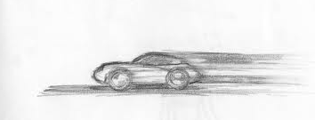
Chapter 5 Motion
Vocabulary Review

Section 1 – Describing Motion

- ____________________ is a change in an object’s position relative to a reference point
- _____________________ is a chosen point used to determine an object’s position
- _____________________ has an SI unit of meters
- _____________________ the distance and direction of the object’s change in position
- _______________________ a type of arrow that has both direction and magnitude
- ______________________ is the distance an object travels per unit of time
- _______________________ a type of speed where you neither speed up or slow down
- _______________________ a speed that is not constant
- _________________________ a type of changing speed that is described as the total distance divided by total time
- ________________________ a type of changing speed that is shown at a specific point in time
- _______________________________ a type of graph used to describe motion in units of meters per second

Section 2 – Velocity & Momentum

- ______________________ includes the speed of an object and the direction of its motion
- ______________________ the product of an object’s mass and velocity
- ________________________ have been drifting apart in a motion known as continental drift

Section 3 – Acceleration

- _______________________ is the rate of change of velocity
- ________________________ a type of graph that can be used to measure acceleration (usually in meters/second divided by seconds)
- __________________________________ a type of acceleration towards the center of a curved or circular path

