Chapter 5 Review Worksheet
(Sections 5.1-5.3)

- Which of the following objects would have the greatest momentum if they were all moving at the same velocity?
  - Car
  - Bus
  - Truck
  - Bicycle
- Compare and contrast the following pairs of terms:
  - Speed-velocity

  - Motion-displacement

  - Velocity-momentum

  - Acceleration-velocity

- Which of the following do you calculate when you divide the total distance traveled by the total time traveled?
  - Average speed
  - Constant speed
  - Variable speed
  - Instantaneous speed
- Which of the following is the SI unit of acceleration?
  - s/km²
  - km/hr
  - m/s²
  - cm/s
- Which of the following is not used in calculating acceleration?
  - Initial velocity
  - Average speed
  - Time interval
  - Final velocity

- In which of the following conditions does the car not accelerate?
  - A car moves at 80km/h on a flat, straight highway
  - The car slows down from 80km/hr to 35km/hr
  - The car turns a corner
  - The car speeds up from 35km/hr to 80km/hr
- How is speed defined?
  - Acceleration/time
  - Change in velocity/time
  - Distance/time
  - Displacement/time
- Which best describes why projectiles move in a curved path?
  - They have constant horizontal velocity and vertical acceleration
  - They have horizontal acceleration and constant vertical velocity
  - They have horizontal momentum and constant vertical velocity
  - They have horizontal acceleration and vertical momentum

Use the following table to answer question #9.
Distance-Time for Runners
Time(s) | 1 | 2 | 3 | 4
Sally’s Distance (m) | 2 | 4 | 6 | 8
Alonzo’s Distance (m) | 1 | 2 | 2 | 4

- Make a distance-time graph that shows the motion of both runners. What is the average speed of each runner? Which runner stops briefly? Over what time interval do they have the same speed?

10. Fill in the blanks for the following figure:
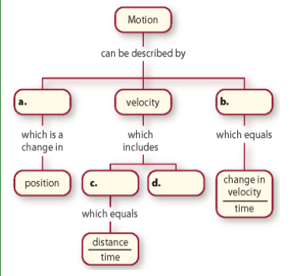

- Which of the following represents the greatest speed?
  - 20m/s
  - 200cm/s
  - 0.2km/s

- Acceleration can occur when a car is moving at a constant speed. What must cause this acceleration?

- If you walked 20m, took a book from a lab table, and walked back to your seat, what are the distance you traveled and your displacement? Explain.

- A rocket travels in a straight line at a speed of 5,000m/s. After 1 min, it is 10,000m/s. What is the rocket’s acceleration?

- Calculate the momentum of a 145kg emu running east at 12.5m/s. Show your work.

- A ATV accelerates at an average rate of 1.3m/s². Calculate how long it takes the ATV to accelerate from 12.6m/s to 15.9m/s. Show your work.

- Calculate the distance in meters a car would travel in 8 hours at an average velocity of 25km/h to the north. Show your work.

- Find the velocity in meters per second of a jet flying 56km northeast in 12.3s. Show your work.

- What is the mass of a train whose momentum is 1200 kg×m/s and has a velocity of 25m/s? Show your work.

