5.3 Notes Outline
Acceleration

Acceleration Free Write
- In the space provided write down what you know about the following questions:
  - What happens to acceleration when you slow down?

  - If you throw a ball straight up, what happens to the acceleration?

  - What is the acceleration when the ball as at the peak height (where it can no longer go up and has not yet begun to fall)?

- _________________________: the rate of change of velocity
  - Units: ___________________
  - Remember: velocity is a change in _______________ or _____________________
- Acceleration occurs when an objects changes its _________________, its ____________________, or both
- When an object travels in a straight line and does not change direction, a graph of _______________ vs time can provide info about the object’s acceleration.
- The slope on a speed-time graph equals the object’s ___________________________

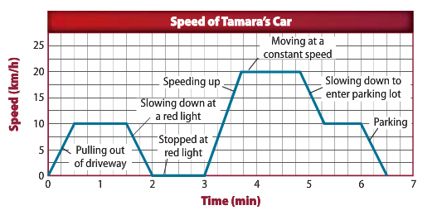
    - Identify and label the places on the graph where acceleration is occurring

- _______________________: the rate of change in velocity (m/s²)
- Acceleration Equation:
  - Acceleration (m/s²) = change in __________________ (m/s)
_________________ (s)
a= V_{f} – V_{i}
t
    - In some cases, your calculations will result in a _____________________ acceleration. The negative sign for acceleration means in the ______________________direction.
Circular Motion
- _____________________ _______________________: acceleration toward the center of a curved or circular path

Projectile Motion
- Horizontal and vertical motion
  - When you throw or shoot an object the force exerted by your hand give the object ______________________ velocity. The horizontal velocity is ____________________.
  - When you release a rubber band, gravity causes it to accelerate ________________________ causing the rubber band to have ____________________ vertical velocity
Throwing vs Dropping
- If you throw a ball as hard as you could in a perfectly horizontal direction, would it take longer to reach the ground than if you dropped the ball from the same height? --- Actually it would not!
- The __________________ distance traveled by both objects is the same.
- The ___________________ distance travelled by the thrown object is greater. (This means the energy spent on throwing the ball is used by traveling a greater distance __________________ .)

Types of Acceleration Activity
- In groups, demonstrate three ways to accelerate while walking.
  - Keep in mind the definition of acceleration (a change in velocity divided by a change in time)
- Be ready to verbally justify your reasoning and explain why walking at a constant speed is not accelerating
- Write down your three methods of acceleration and explain your reasoning in the space below:

